AUGUST 24, 2013 THESKEPTICARENA.COM

Top terrible comments about Atheist soldiers on FoxNews.com

(most come from a story about the removal of crosses
from a chapel in Afghanistan)

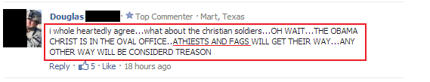

Sometimes a comment is so stupid, no reply is necessary. The thing to notice about this comment is that there were actually 5 people who gave it a thumbs up.

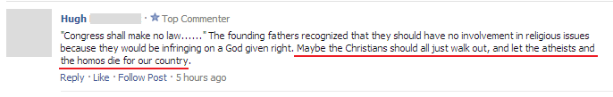

Hugh, without Christians and Muslims, where would you even find a war?

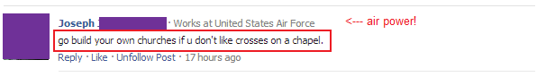

Joseph, you don't seem to be getting the picture here: Atheists don't have churches.

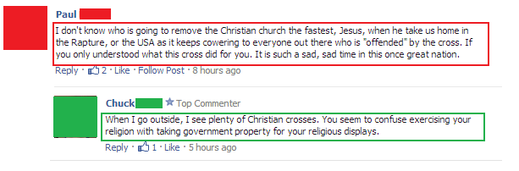

Paul, we are more than aware of what the Christian cross has meant to humanity; and the sooner it's gone ... the better off humanity will be.

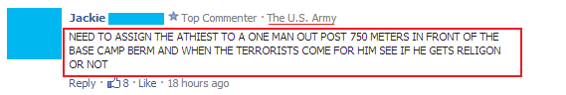

Jackie, if such a moment should occur, the last thing that soldier needs to worry about is asking for help from an invisible ghost.

(see replies)

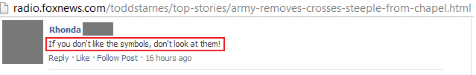

Rhonda, we don't have to ... they came down. We won - you lost.

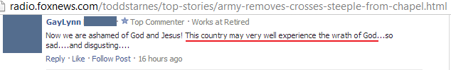

GayLynn, if you had been keeping up on current events, you would know that we already have been experiencing the wrath of God.

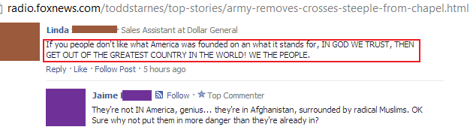
Linda, dear precious ignorant Linda, 'in God we trust' was added nearly 200 years after the founding of our country.

But I noticed that you did quote 'we the people' showing that you do know who really founded America.

Jaime also made a great reply.

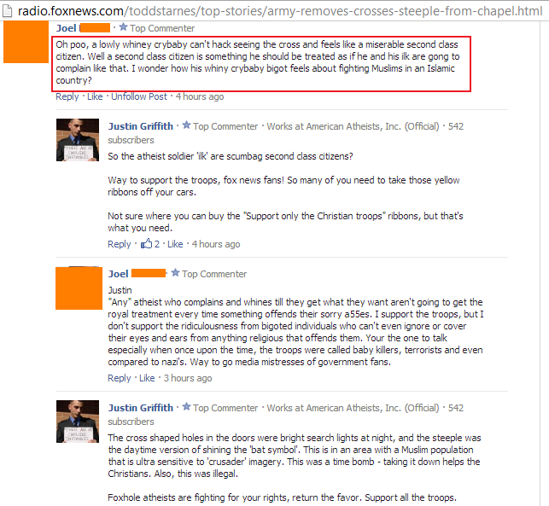

That was a great exchange. I estimate an I.Q. difference of around 50 points. I'll let the listeners decide ... in whose favor.

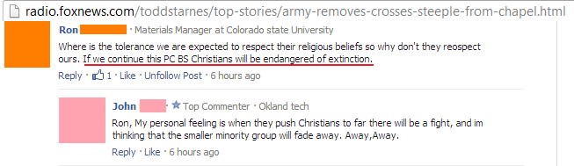

Ron, Christians are an endangered species. Google it yourself.

John, history proves that when minority groups challenge Christians they don't fade away ... they are eliminated.

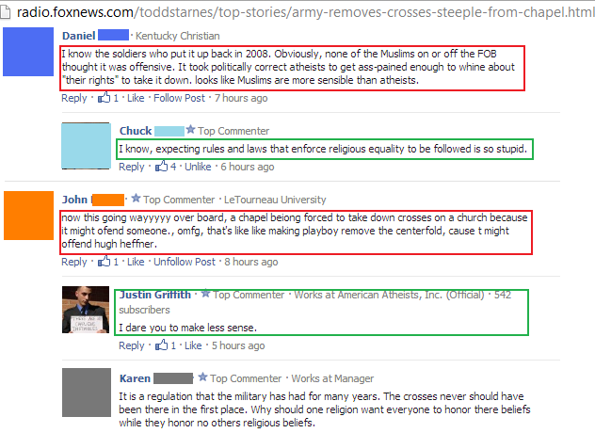

Great replies, making mine ... unnecessary.

Once again, I defer to the commenters who basically ... kicked Kenny's ass.

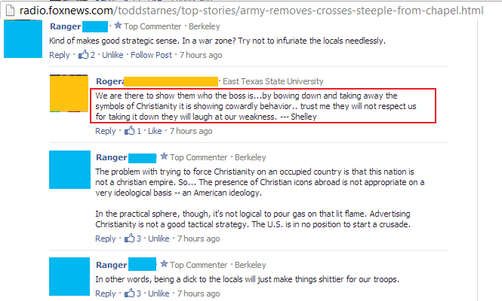

Roger, you are making Christians look like idiots. Well okay, Ranger also made you look like an idiot.

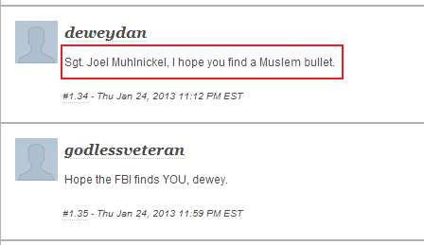

Deweydan, get into therapy. Oh, and when you go: please do not take any sharp objects with you.

AND THE BEST COMMENT WAS ...

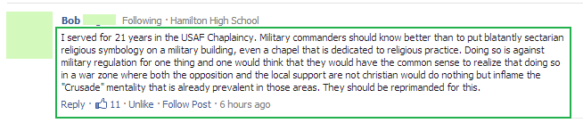

Thanks Bob, for ending this Fox News fiasco on a note of sanity.
****************************************************

THE SCIENCE SEGMENT

Researchers Debunk the Myth of
"Right-brain" and "Left-brain" Personality Traits

Chances are, you’ve heard the label of being a “right-brained” or “left-brained” thinker. Logical, detail-oriented and analytical? That’s left-brained behavior. Creative, thoughtful and subjective? That's right-brained behavior; or so we've been told. But newly released research findings assert that there is no evidence within brain imaging that indicates some people are right-brained or left-brained.

For years in popular culture, the terms left-brained and right-brained have come to refer to personality types, with an assumption that some people use the right side of their brain more, while others use the left side more. Following a two-year study, researchers have debunked that myth through identifying specific networks in the left and right brain that process lateralized functions.

Lateralization of brain function means that there are certain mental processes that are mainly specialized to one of the brain’s left or right hemispheres. During the course of the study, researchers analyzed resting brain scans of about a thousand people between the ages of 7 and 29. In each person, they studied functional lateralization of the brain measured for thousands of brain regions —finding no relationship that individuals preferentially use their left-brain network or right-brain network more often.

It’s absolutely true that some brain functions occur in one or the other side of the brain. Language tends to be on the left - attention more on the right. But people don’t tend to have a stronger left or right-sided brain network. It seems to be determined more, connection by connection.

Researchers obtained brain scans for the population they studied from a database called the International Neuroimaging Data-Sharing Initiative. The participants’ scans were taken during a functional connectivity MRI analysis, meaning a participant lay in a scanner for 5 to 10 minutes while their resting brain activity was analyzed.

By viewing brain activity, scientists can correlate brain activity in one region of the brain compared to another. In the study, researchers broke up the brain into 7,000 regions and examined which regions of the brain were more lateralized. They looked for connections — or all of the possible combinations of brain regions — and added up the number of connections for each brain region that was left-lateralized or right-lateralized. They discovered patterns in brain imaging for why a brain connection might be strongly left or right-lateralized.

If you have a connection that is strongly left-lateralized, it relates to other strongly lateralized connections only if both sets of connections have a brain region in common.

We just don't see patterns where the whole left-brain network is more connected or the whole right-brain network is more connected in some people. It may be that personality types have nothing to do with one hemisphere being more active, stronger, or more connected.
****************************************************

FAMOUS QUOTES

Montesquieu (1689 – 1755) 66 years

He was a French social commentator and political thinker who lived during the Age of Enlightenment. He is famous for his articulation of the theory of separation of powers, which is taken for granted in modern discussions of government and implemented in many constitutions throughout the world.

“No kingdom has ever had as many civil wars as the kingdom of Christ.”

